**GARAGE MANAGEMENT SYSTEM**

College Name: Sasurie College of Arts and Science

College Code: 5Y

Team ID: NM2025TMID25205

**TEAM MEMBERS:**

Team Leader Name: Sterle.J

Email: sterle2006@gmail.com

Team Member 1: Aswin Kumaran.R

Email: ashwinkumaran43@gmail.com

Team Member 2: Bharath.K

Email: bharathkrish692@gmail.com

Team Member 3: Kirubha Sri.P

Email: kirubhasri385@gmail.com

**INTRODUCTION:**

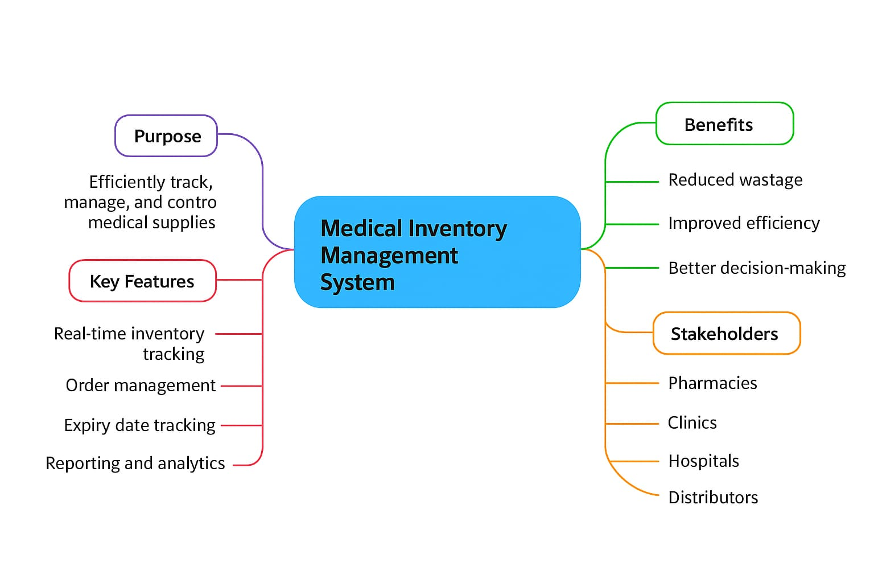 A Garage Management System (GMS) is a digital solution designed to streamline the operations of automotive garages and workshops. Traditionally, many garages rely on manual methods for handling customer details, vehicle records, service schedules, billing, and inventory management, which often leads to errors, delays, and inefficiency. A computerized system eliminates these challenges by providing an integrated platform where all activities can be managed more efficiently.

The system enhances customer satisfaction by maintaining accurate service records, improving transparency, and ensuring timely maintenance reminders. For garage owners and staff, it reduces paperwork, improves data accessibility, and supports better decision-making through reports and analytics.

**PURPOSE**

The purpose of a Garage Management System is to streamline and automate the daily operations of a garage, such as vehicle servicing, repair tracking, and inventory management. It helps in maintaining customer records, generating invoices, and monitoring staff performance. By reducing manual errors and saving time, it ensures efficient workflow and better customer satisfaction. Ultimately, it improves productivity, transparency, and profitability for the garage.

**DEVELOPMENT PHASE**

**Creating Developer Account:**

By using this URL: <https://developer.salesforce.com/signup>



* **Creating a Custom Object:**

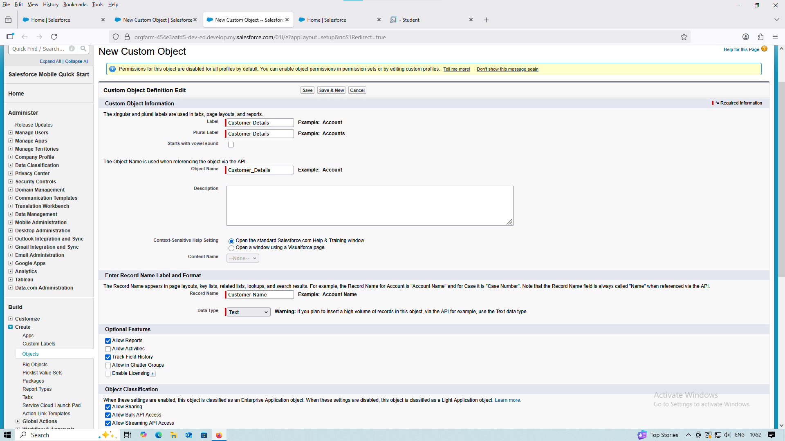

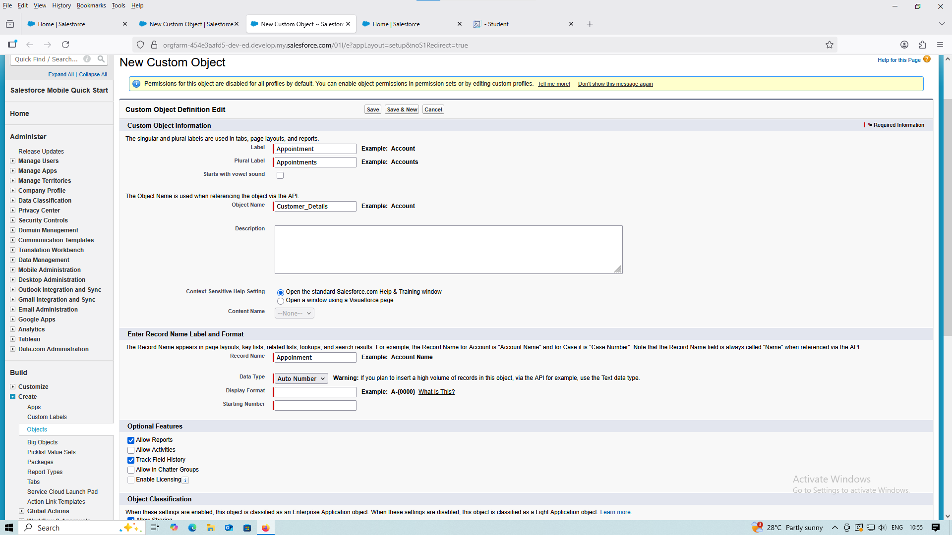

* **Creating a Custom Tabs:**

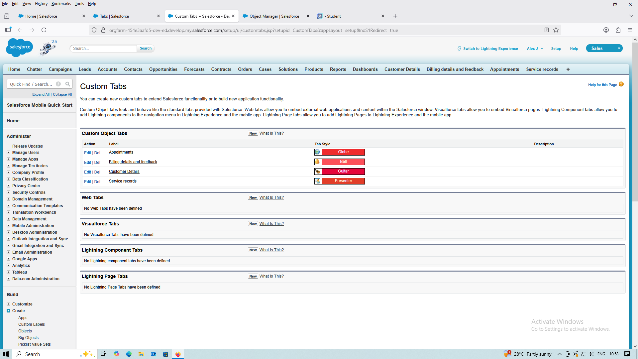

* **Creating Lightning App:  
  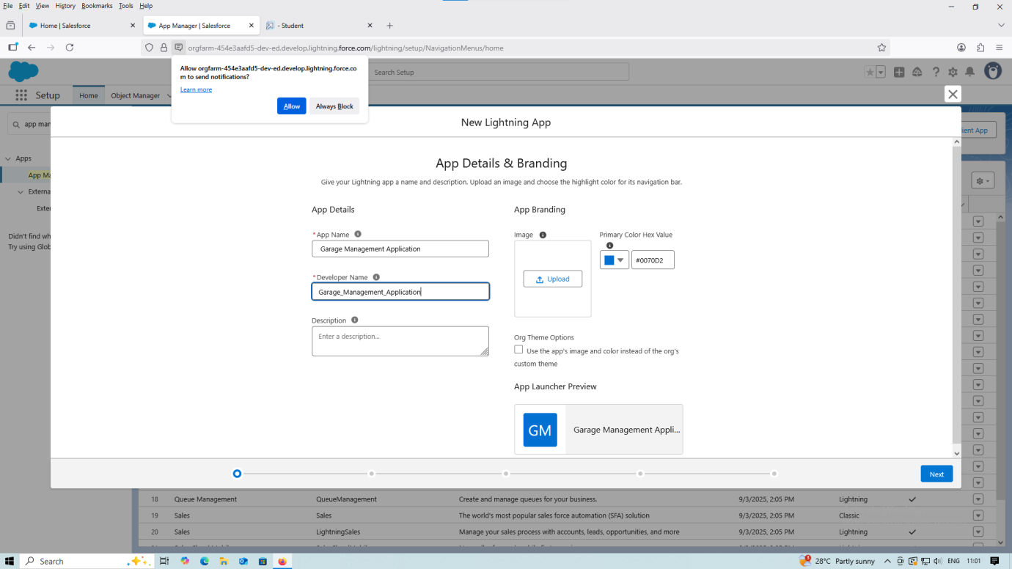**

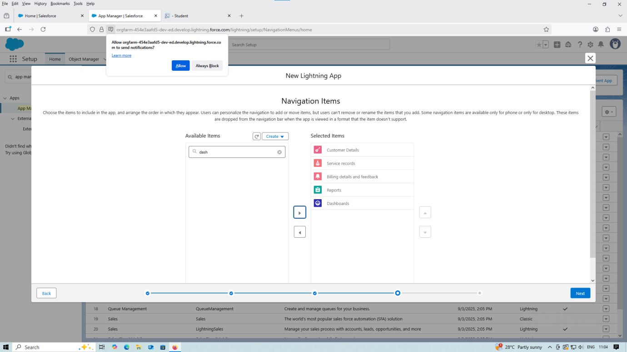

* **Creating New Custom Field:  
  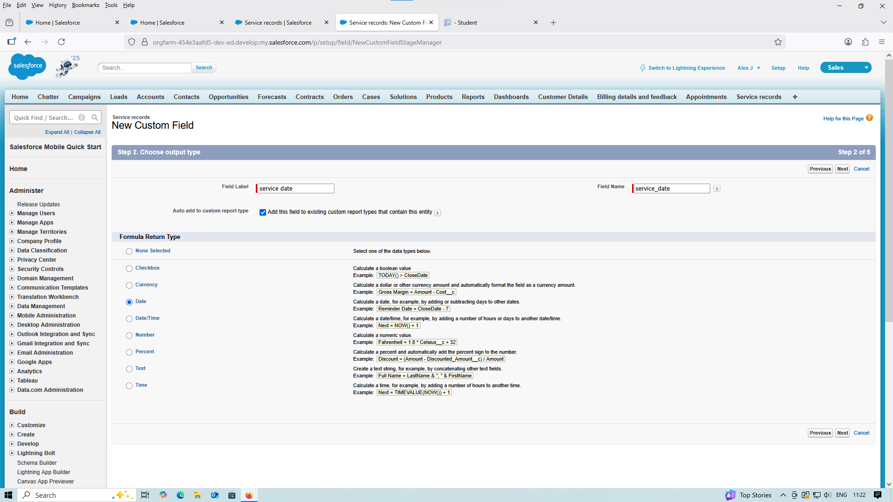**

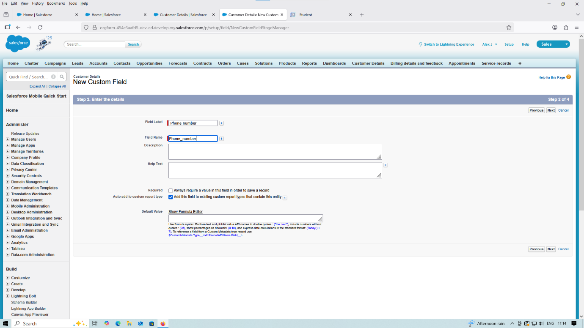

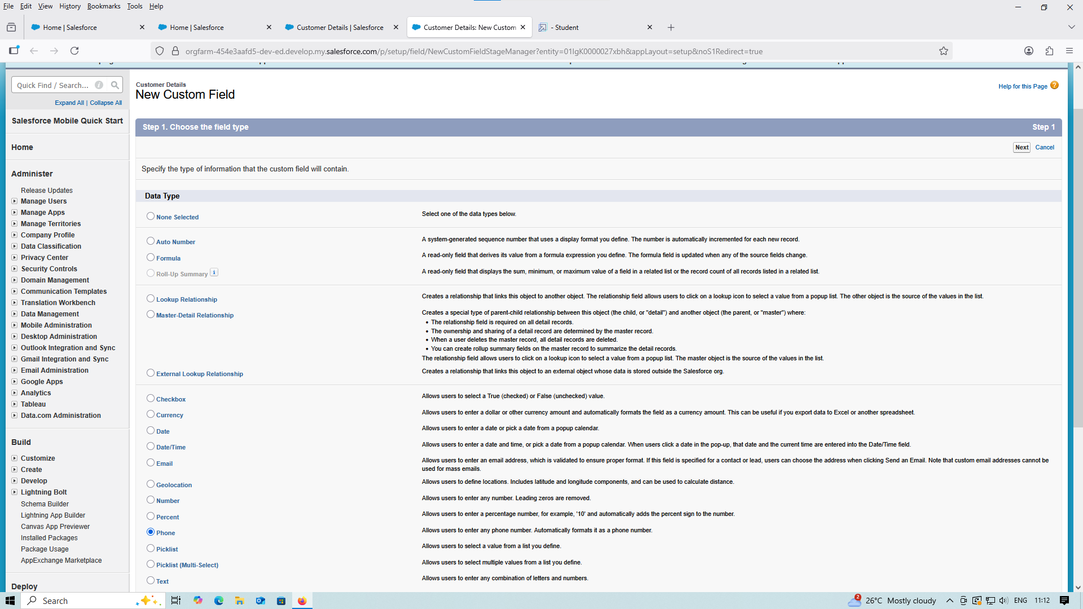

* **Appointment Validation Rule :**

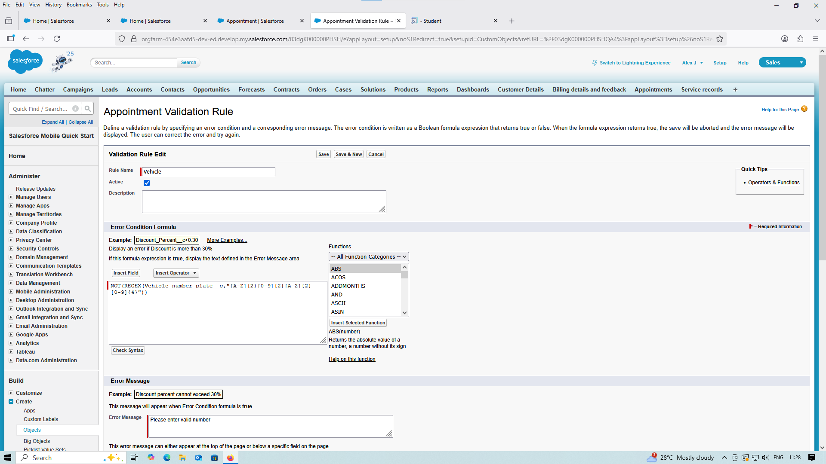

* **Creating Matching Rule:**

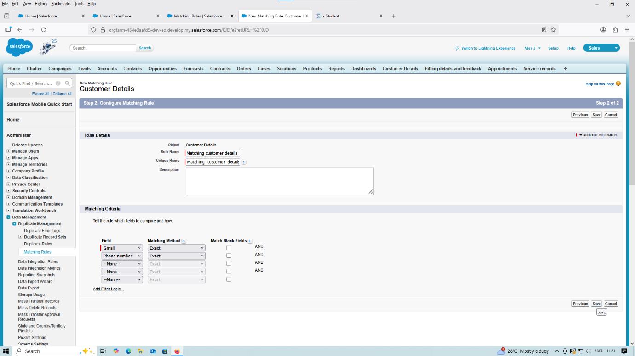

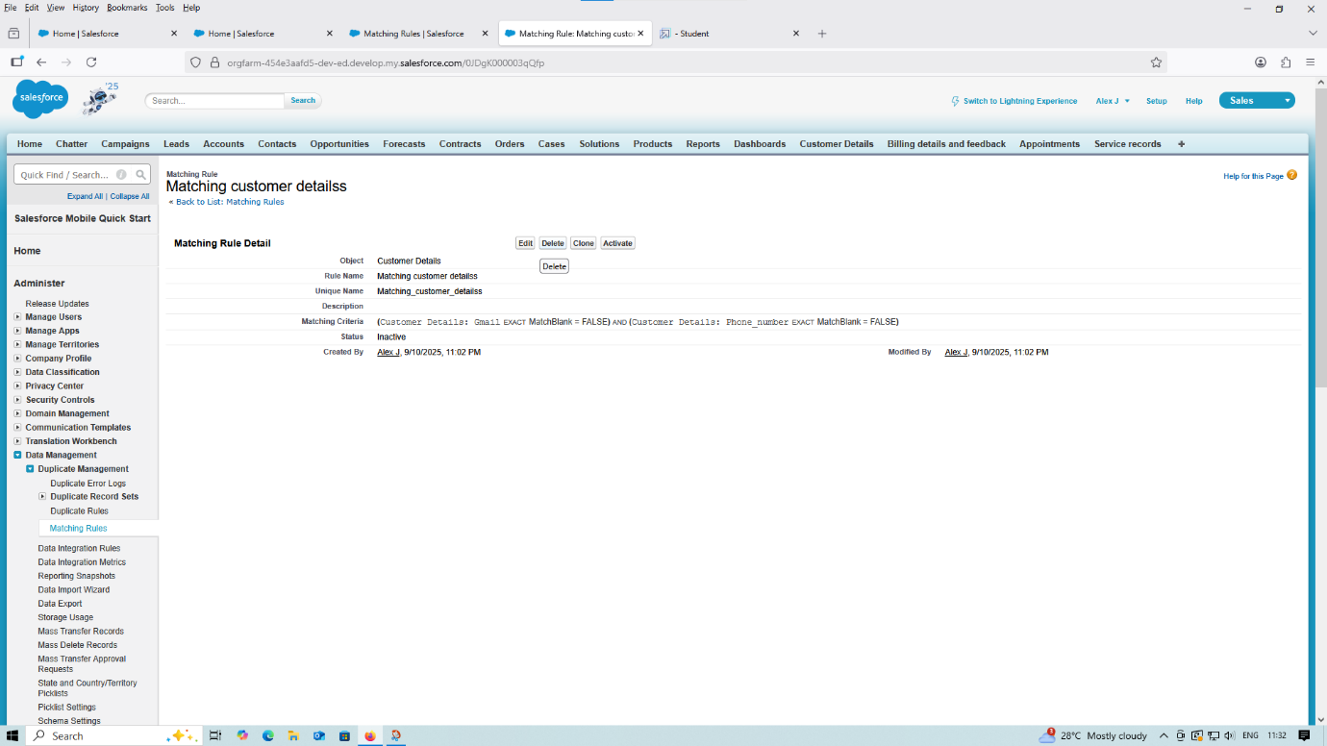

* **Creating Profiles:**

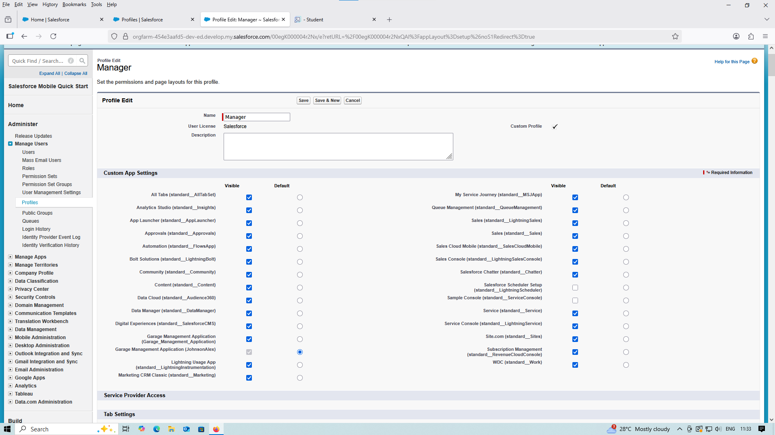

* **Setting up Roles:**

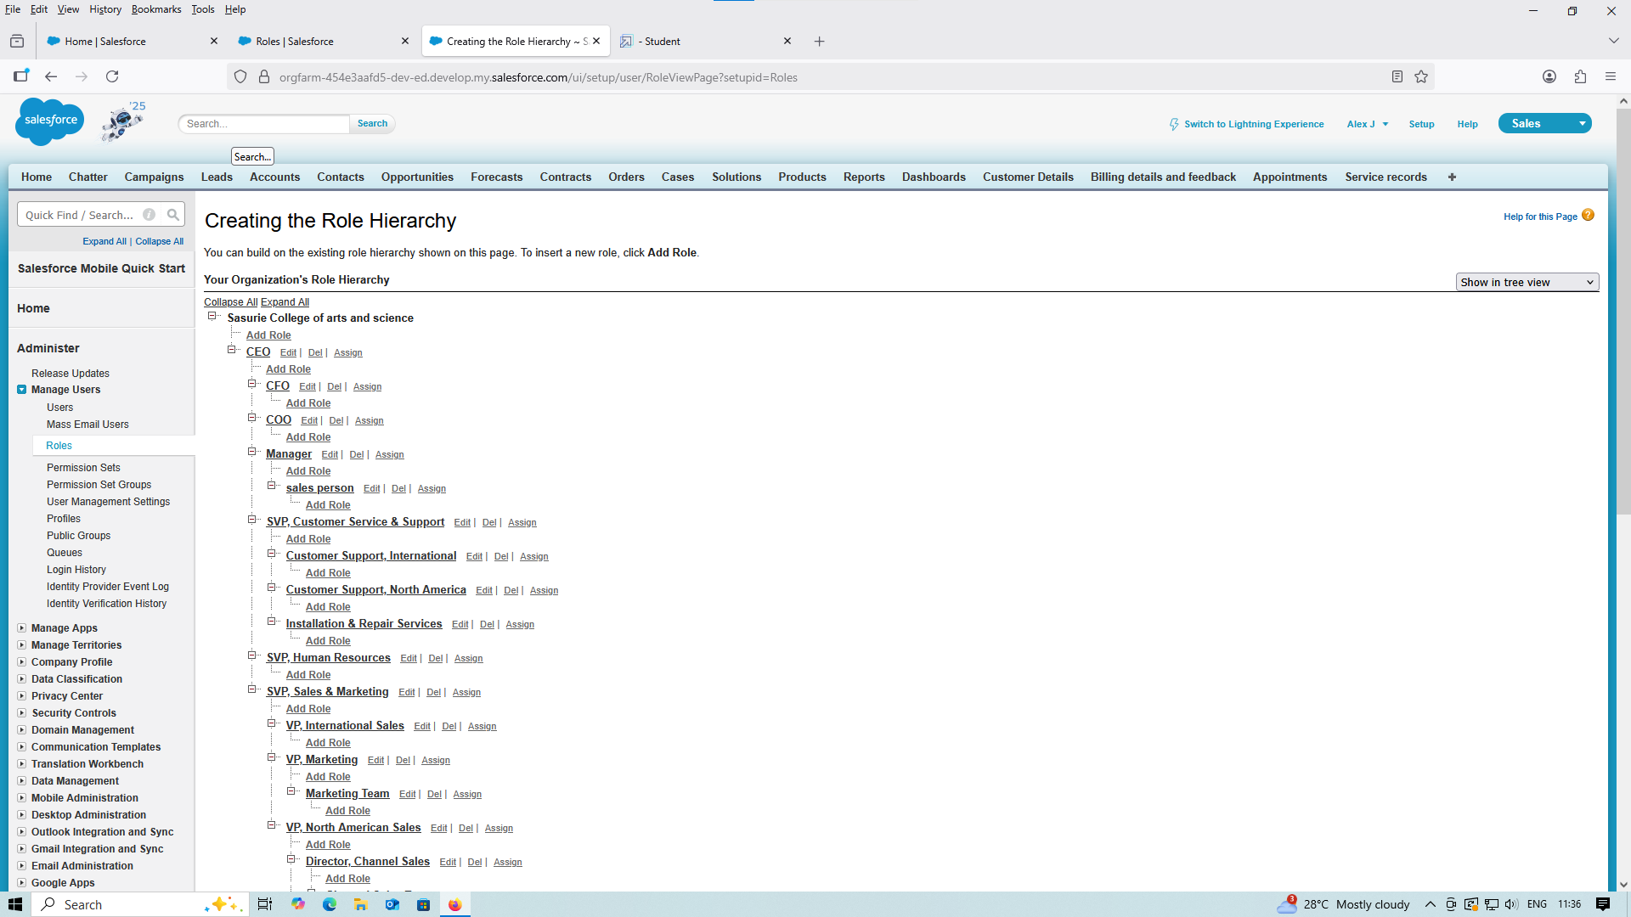

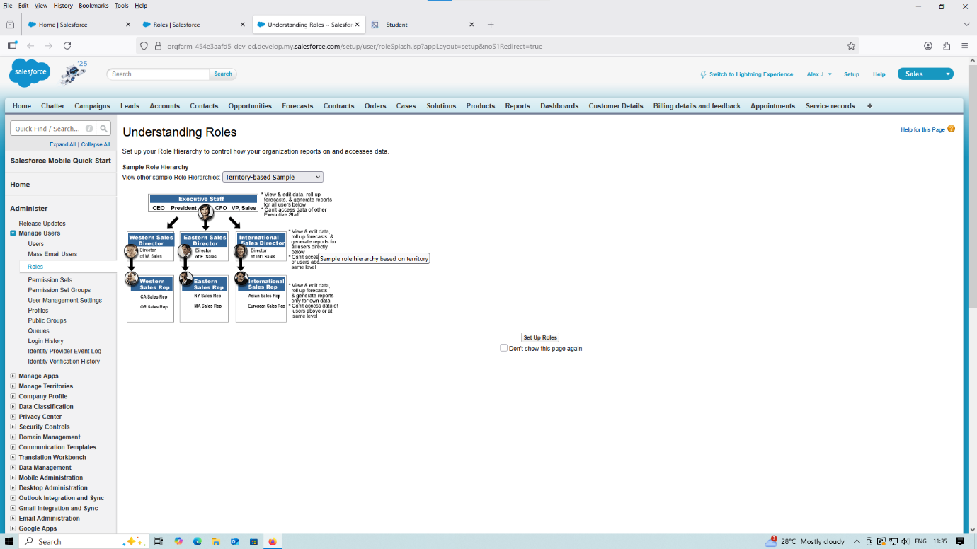

* **Creating User:**

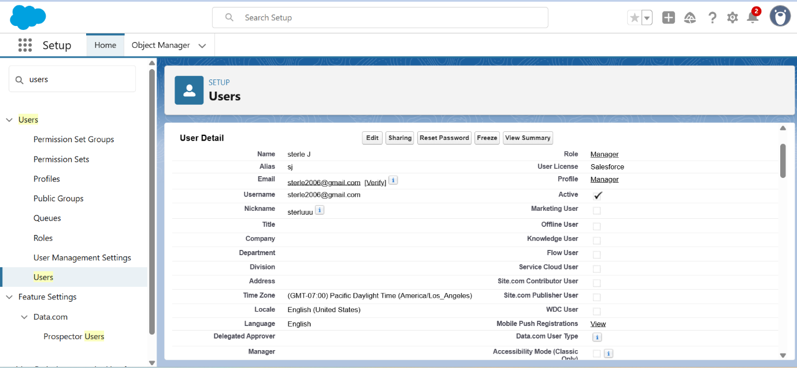

* **Creating New Group:**

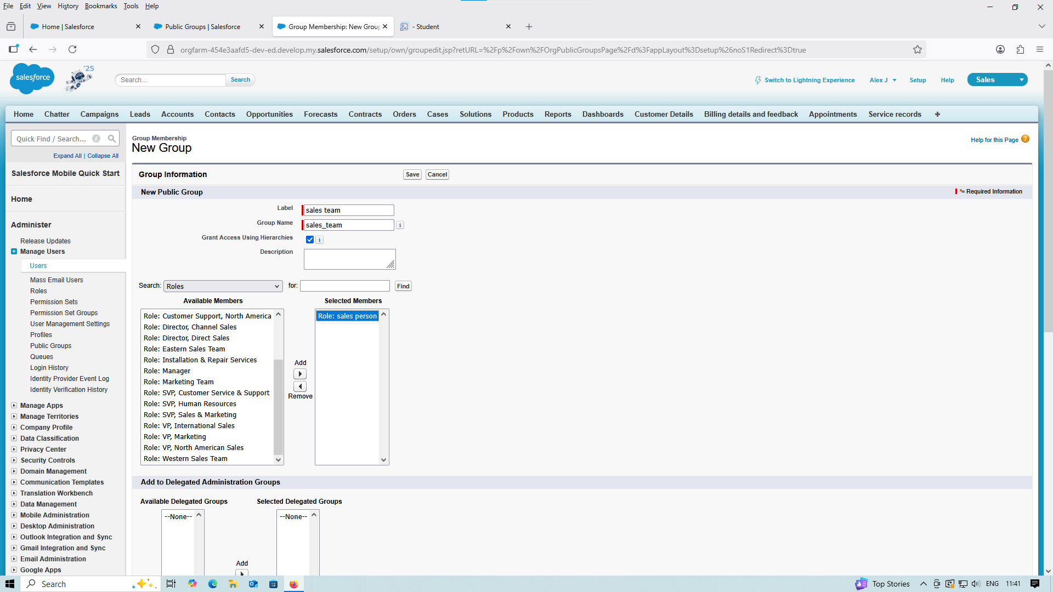

* **Creating Organization:**

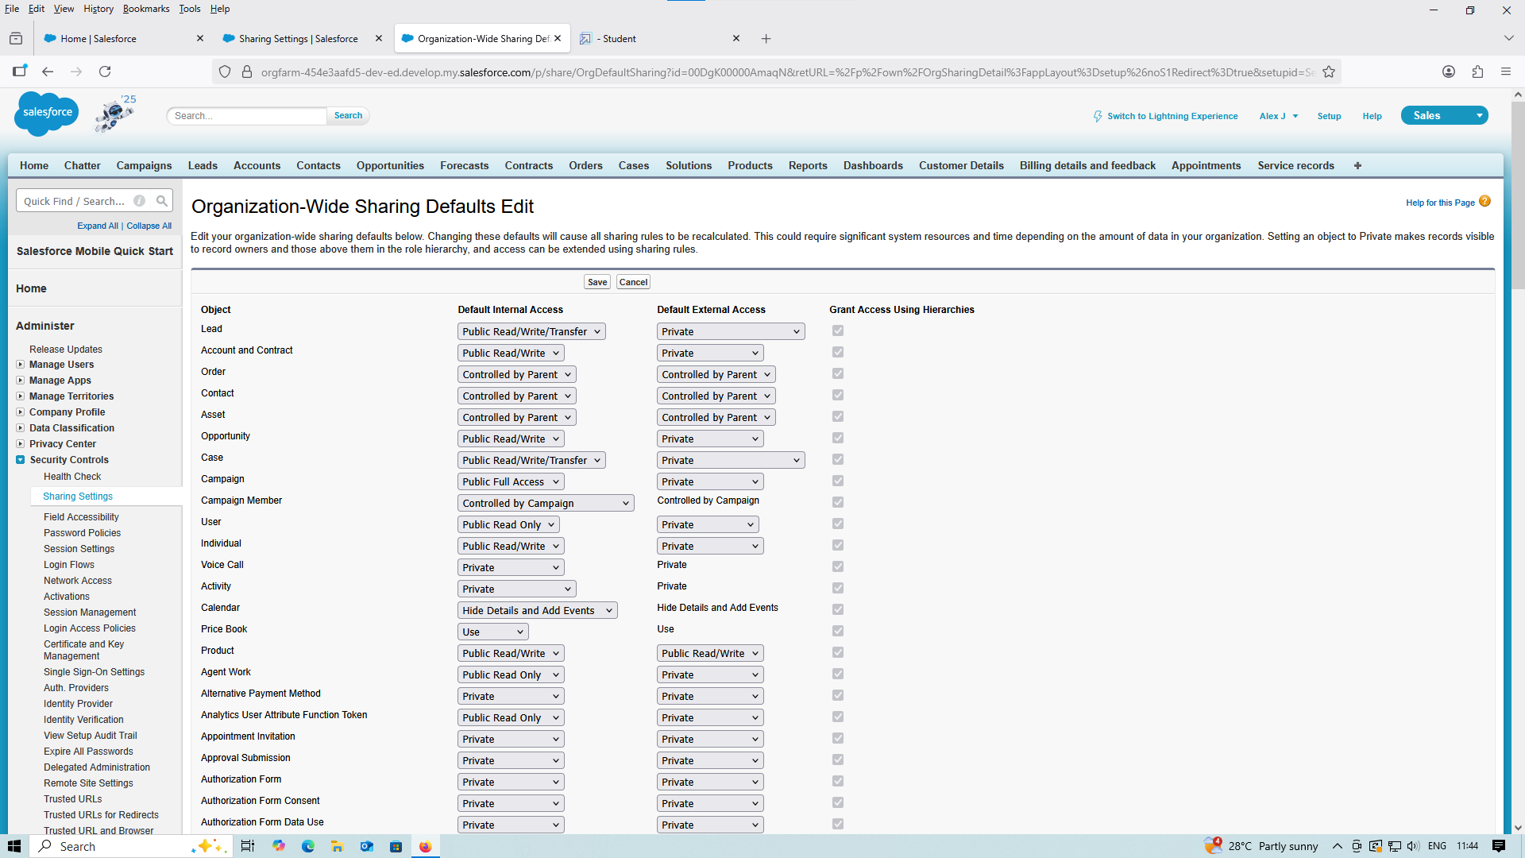

* **Creating Flow Builder:**

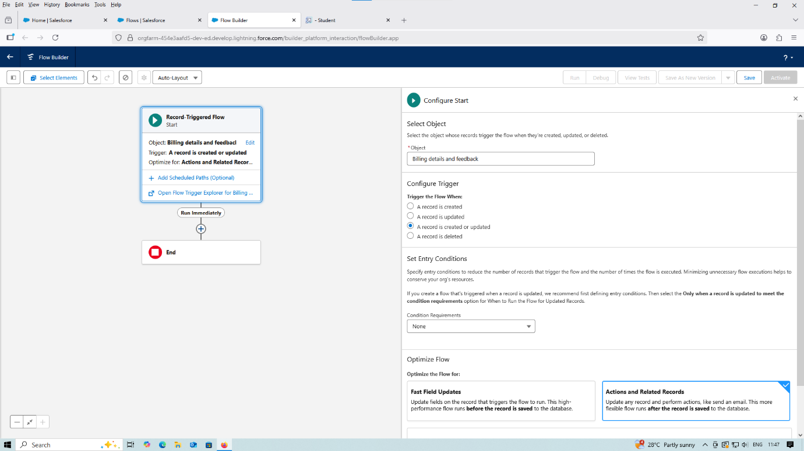

* **Add Element:**

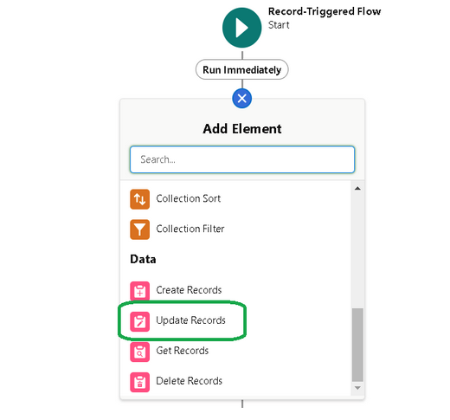

* **Amount Distribution Handler:**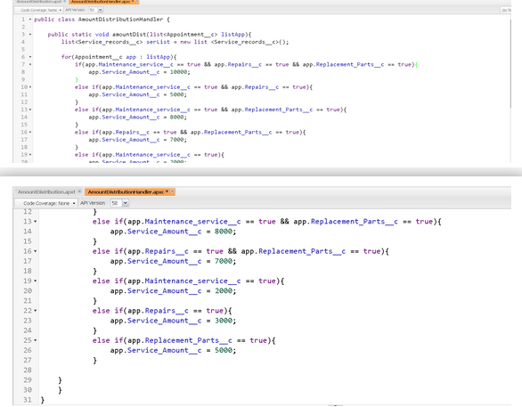

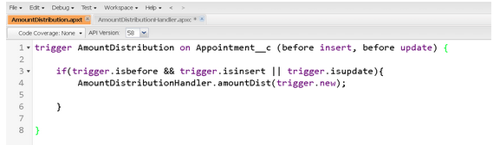

* **Creating a Folder:**

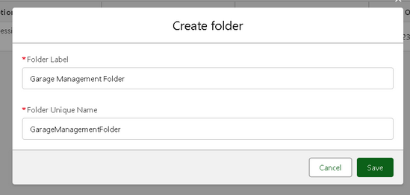

* **Creating Reports:**

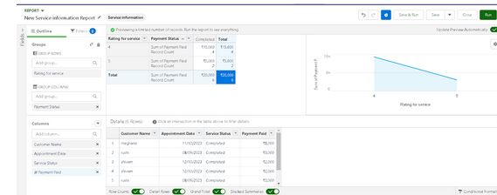

* **Creating a Folder:**

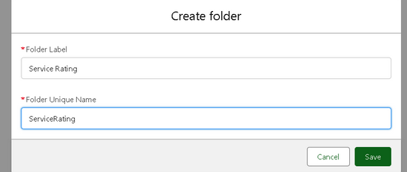

* **New Service Information Report**

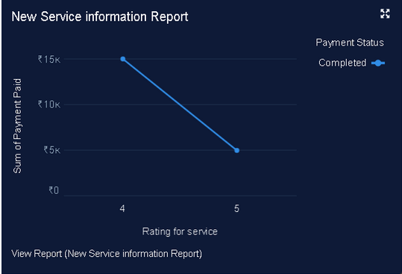

* **Dashboard:**

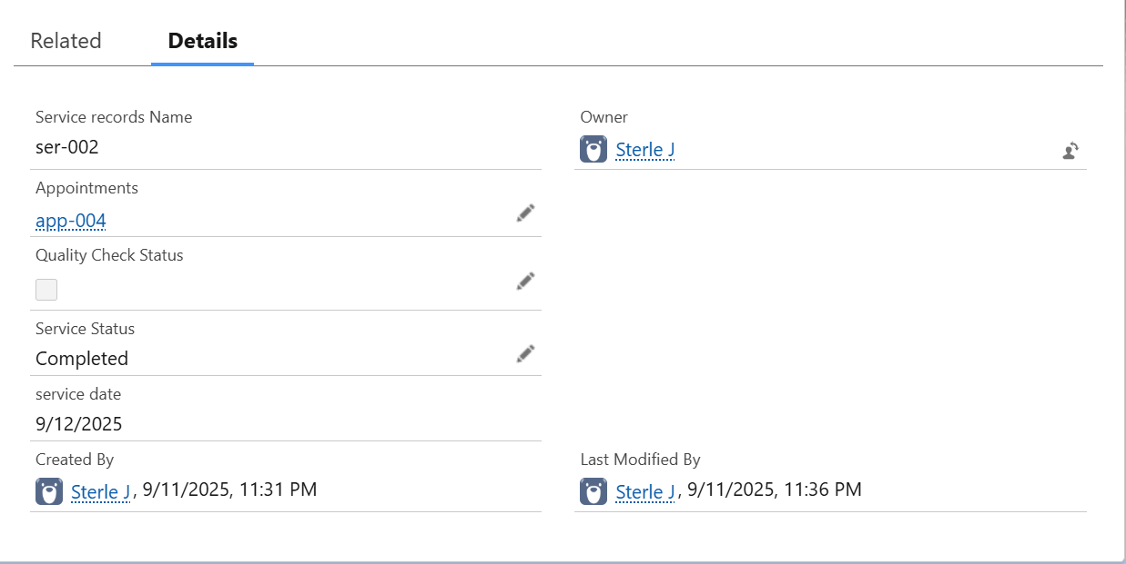

### Conclusion

A Garage Management System is a vital tool for modernizing automotive service operations. It minimizes human error, saves time, and optimizes resources, resulting in improved efficiency and customer satisfaction. By automating routine tasks and centralizing data management, the system allows garage owners to focus more on service quality and business growth rather than administrative burdens.